Threat Intelligence for SOC

Aim:
To understand and apply Threat Intelligence techniques for improving security operations by detecting and preventing malicious activities using IOCs and security tools.

Room Link:: https://tryhackme.com/room/threatintelligenceforsoc

Task 1 — Introduction

Is your organisation prepared to handle emerging threats like new malware IOCs or zero days? And in any case, can you determine unknown adversaries or apply known indicators from reliable sources in your Security Operations pipeline?

Such questions arise when you think of the ever-going cat-and-mouse game of threat actors and security analysts on a typical day. As a group working to secure an organisation, the security team is expected to be prepared to handle the never-ending evolution of threats and anticipate unknown possibilities of potential compromises. Doing all these might be challenging, but you are not alone in this battle.

Learning Objectives

In this room, we will highlight the impact of Threat Intelligence in the Security Operations pipeline; how important information shared across different groups can be utilised by your organisation. In addition, we will tackle topics such as the following throughout the room:

- Threat Intelligence Consumers and Producers
- Types of Threat Intelligence
- Utilising Threat Intelligence to Prevent and Detect malicious activities

Room Prerequisites

It is highly suggested to clear the following rooms first before proceeding with this room:

- Threat Intelligence Tools
- Introduction to Detection Engineering
- Tactical Detection
- Investigating with ELK 101

Let’s put our intelligence to work and stay ahead of potential threats with Threat Intelligence.

Task 2 — Threat Intelligence Feeds Threat Intelligence Recap
For a quick review, let’s reiterate the definition of Threat Intelligence discussed in the Intro to Cyber Threat Intel room.

Threat Intelligence is the analysis of data and information using tools and techniques to generate meaningful patterns to mitigate against potential risks associated with existing or emerging threats targeting organisations, industries, sectors or governments.

There are different classifications of Threat Intelligence, and the primary types of it are:

- Strategic Intel: High-level intel that looks into the organisation’s threat landscape and maps out the risk areas based on trends, patterns and emerging threats that may impact business decisions.
- Technical Intel: Examines evidence and artefacts of attacks an adversary uses. Incident Response teams can use this intel to create a baseline attack surface to analyse and develop defence mechanisms.
- Tactical Intel: Assesses adversaries’ tactics, techniques, and procedures (TTPs). This intel can strengthen security controls and address vulnerabilities through real-time investigations.
- Operational Intel: Assesses an adversary’s specific motives and intent to perform an attack. Security teams may use this intel to understand the critical assets available in the organisation (people, processes, and technologies) that threat actors may target.

These classifications may give you an idea of how you operate with the data. But our only focus in this room is on Technical Intel, utilising artefacts generated by adversaries to improve the Security Operations pipeline. This type is the most common of the four classes and is mainly known as IOC-based Threat Intelligence.

Before applying Threat Intelligence to Security Operations, let’s first deal with your understanding of how organisations differ in roles regarding Threat Intelligence.

Consumers and Producers

Do you build the knowledge base, or do you consume the knowledge of others?

The common notion of Threat Intelligence is the dataset of known bad IOCs collated by different entities. It may be malicious URLs hosting malware or IP addresses of suspicious connections. But would you know how this information is gathered for the disposal of security analysts? Let’s first differentiate the concept of Producers and Consumers of Threat Intelligence.

Producers
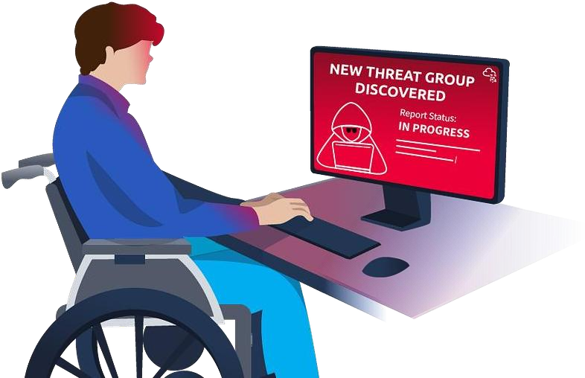

Threat Intelligence Producers gather, analyse and disseminate threat intelligence data for others and themselves. These Producers create reports, advisories, and resources that are shared within the broader cybersecurity community. This group includes cybersecurity vendors, research labs and organisations specialising in collecting and interpreting data on emerging cyber threats.

Now, the Producers typically collect data using various methods and techniques. Standard methods include network monitoring, which involves monitoring an organisation’s network traffic to identify abnormal behaviour from the inside or a honeypot server exposed externally.

Another example could be a collection of IOCs based on internal incidents handled by an organisation. These organisations expect a more significant number of incidents compared to small organisations with fewer assets to be compromised or user activity to be monitored. The results of these collections are then further analysed, attributed to potential threat actors, and published eventually to help other organisations.

These examples summarise that not every organisation can be a Producer. It requires a vast set of collected data, the capacity to determine expected normal behaviour, and the capability to analyse and pinpoint unknown potential threats.

Consumers

On the other hand, Threat Intelligence Consumers are organisations or individuals who consume Threat Intelligence created by Producers. The information gathered from different sources is utilised to improve the organisation’s security posture.

How does this group typically leverage the intelligence data shared with them?

- Identifying vulnerabilities — Consumers can use published vulnerabilities discovered due to zero days launched by threat actors to identify vulnerabilities in an organisation’s infrastructure. Advisories such as CVE publications are commonly utilised to determine if an organisation is impacted by it and apply mitigations if needed.
- Prevention and Detection — Consumers can use IOCs to prevent intrusions by blocking these artefacts or detect them by applying them to threat detection rules.
- Incident Response — Consumers can use intelligence data to respond more effectively to incidents as the data may confirm the likelihood of the attack and the potentially attributed tactics and techniques.
- Collaborating with others — Information sharing is not only for Producers but also for Consumers. Data analysis of IOCs may still require human assessment, so it is helpful to share information that is validated to be beneficial for Security Operations.

Are you a Consumer or a Producer?

Assessing whether your organisation is a Threat Intelligence Consumer or Producer depends on the roles and responsibilities of your security team and the overall cybersecurity strategy of your organisation.

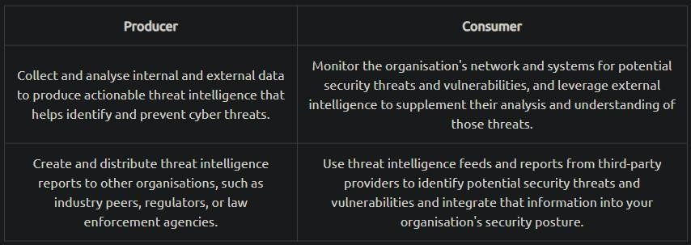

Once you have defined your role, you may also consider assessing your current practices based on the following:
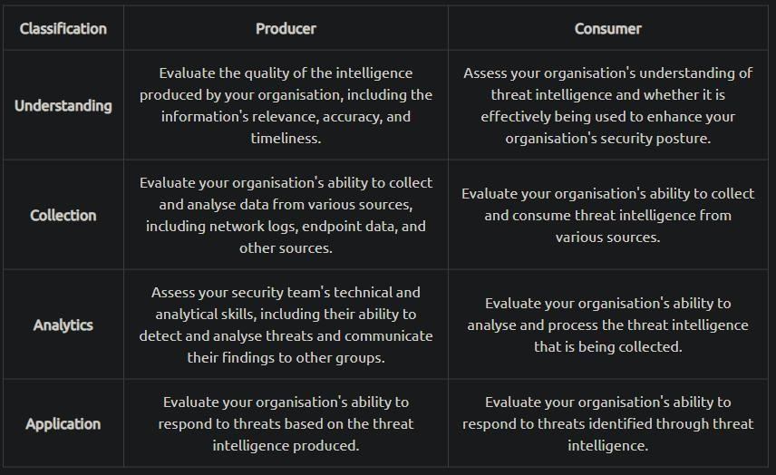

Consuming Threat Intelligence

To conclude this task, we will hunt and consume IOCs provided by Threat Intelligence Producers.

Click on the Start Machine button at the top right corner of this task. The machine provides access to the following:

- SSH access via port 22 with the following credentials:
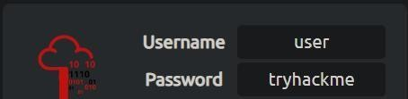

- Kibana Instance via http://[Machine_IP] with the following credentials: elastic:elastic

Note: The Kibana instance takes 3–5 minutes to initialise.

Uncoder.io

Uncoder.io is an online tool that transforms Sigma rules, IOC lists, and other platform query syntaxes into custom hunting queries prepared for execution in SIEM and XDR. It is an easy-to-use tool that could assist us in hunting the following IOCs up for investigation. For IOCs, the tool accepts six different types of IOCs, namely:

- IPs
- Domains
- URLs
- Hashes
- Emails
- Files

Let’s use the following set of IPs and feed them into Uncoder. Do take note that with recent updates, this requires setting up a free account on the uncoder.io website.
ioc_list.txt 117[.]213[.]7[.]8
119[.]180[.]220[.]224
144[.]202[.]127[.]44
119[.]180[.]220[.]224
221[.]15[.]94[.]231

Follow along with the steps and the image below:

- Paste the list of IOCs. Note that defanged IPs will be cleaned, and redundancies will be removed, so only four IPs are detected, as shown below.
- Configure the source platform and set it to IOCs.
- Set the target platform to Elastic Query since the provided SIEM is built on that.
- Click translate and view the produced query syntax.
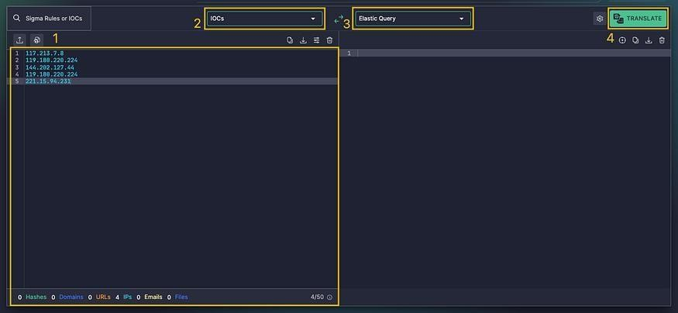

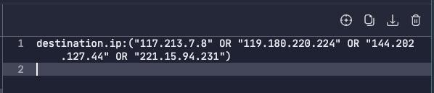

The result of using the tool can be utilised in our Kibana Instance via the Discover feature. Ensure that the query is under the filebeat-* index and searches between 02/14/2023 and 02/17/2023.

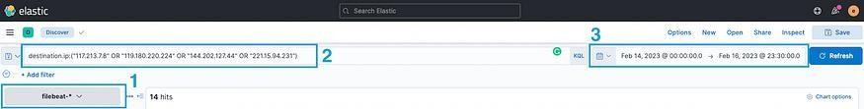

To complete the task, answer the following questions using the set of IOCs below. You must use the same index and timeframe mentioned above.
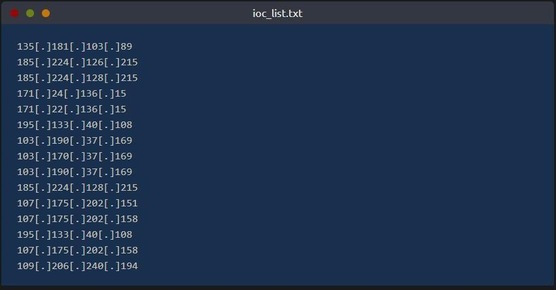

destination.ip:(“135.181.103.89” OR “185.224.126.215”
OR “185.224.128.215” OR “171.24.136.15” OR “171.22.136.15” OR “195.133.40.108” OR “103.190.37.169” OR “103.170.37.169” OR

“103.190.37.169” OR “185.224.128.215” OR “107.175.202.151” OR “107.175.202.158” OR “195.133.40.108” OR “107.175.202.158” OR “109.206.240.194”)

Question:: How many unique IP addresses were provided in the IOC list?

You need to count the Unique IPs the list has duplicants in it.

Answer:: 11

Question:: Based on the set of IOCs, how many IOC hits were discovered in the logs?

Search Query::

destination.ip:("135.181.103.89" OR "185.224.126.215" OR "185.224.128.215" OR
"171.24.136.15"
OR "171.22.136.15" OR "195.133.40.108" OR "103.190.37.169" OR "103.170.37.169"
OR "103.190.37.169" OR "185.224.128.215" OR "107.175.202.151" OR "107.175.202.158"
OR "195.133.40.108" OR "107.175.202.158" OR "109.206.240.194")

Paste it into Elastic Set the time as said in the task and search
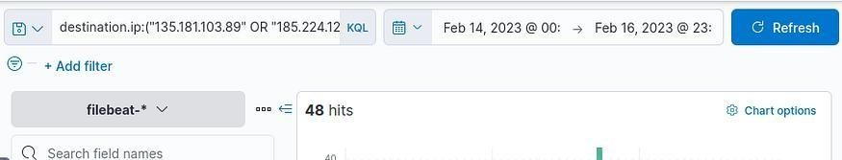

Answer:: 48

Question:: Out of the total number of IOCs, how many unique IP addresses were discovered in the logs?

We got 5 IPs in the top values

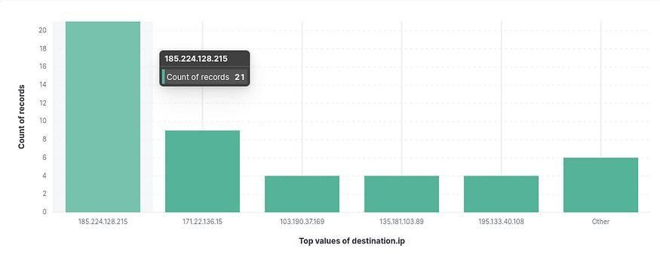

And a further 2 within the others
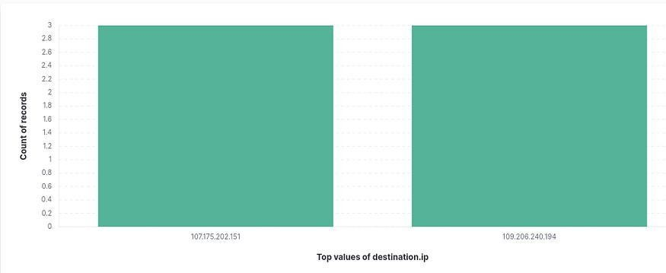

Answer:: 7

Question:: How many connections were made to 185[.]224[.]128[.]215?
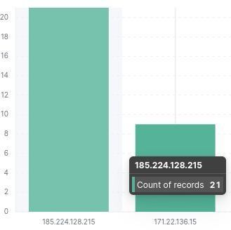

Answer:: 21

Question:: What is the IP address of the compromised host?
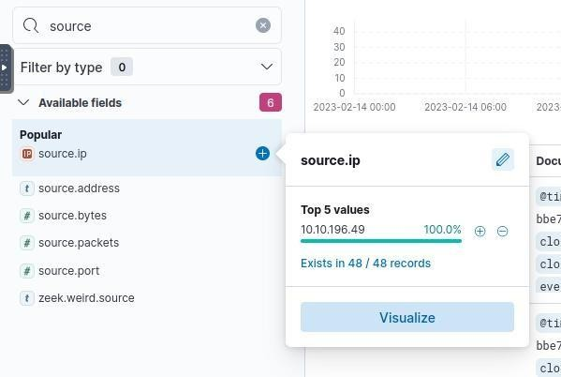

Answer:: 10.10.196.49

Question:: What is the destination port of connections made to 107[.]175[.]202[.]151?

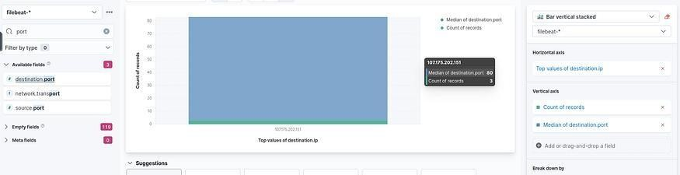
Drag and drop “destination.port’ to Vertical axis for example and you can read it quickly. Press enter or click to view image in full size

Answer:: 80

Task 3 — Intelligence-driven Prevention

Your organisation has determined that you are a consumer of Threat Intelligence from reliable sources; your task is to apply the concepts of being a consumer by deploying controls to prevent threats in your infrastructure.

Using our current knowledge of Threat Intelligence, we will utilise the IOCs from reliable sources to deploy security controls that will prevent malicious activity in our infrastructure.

To start with, we can first simplify the types of IOCs that are commonly distinguished in Threat Intelligence feeds:

- Domains — Typically attributed to URLs used to host malicious files, C2 callbacks or email domains used for spam.
- IP Addresses — Commonly attributed to addresses known to execute attacks seen from external assets or outbound callbacks from malware.

IP Blocking via Firewall

IP blocking is a well-known security measure that involves blocking ingress or egressing network traffic based on the device’s IP address attempting to initiate a network connection. It is typically done using a Firewall, a security system that controls the traffic based on predetermined rules.

Configuring firewall rules could be overwhelming, but having a direction to deny connections from a known malicious IP address is a good start in preventing malicious connections, such as:

- Prevent intrusive connections against external applications that may affect service uptime or compromise via a known vulnerability.
- Prevent connection attempts to the threat actor’s infrastructure after successful malware execution.
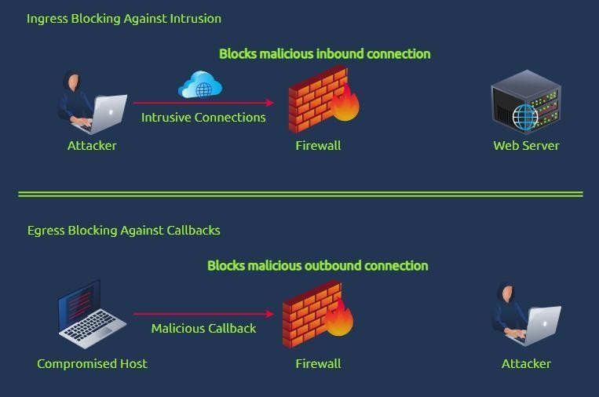

Domain Blocking through Email Gateways

Similar to IP blocking, we can configure Email Gateways to prevent known malicious domains from forwarding incoming email messages based on the sender’s domain. Email

Gateways also depend on a ruleset, which should contain the block list of domains known to send spam or phishing emails. Once the block list is populated, the Email Gateway prevents threat actors from reaching the inbox of the target users in the organisation.
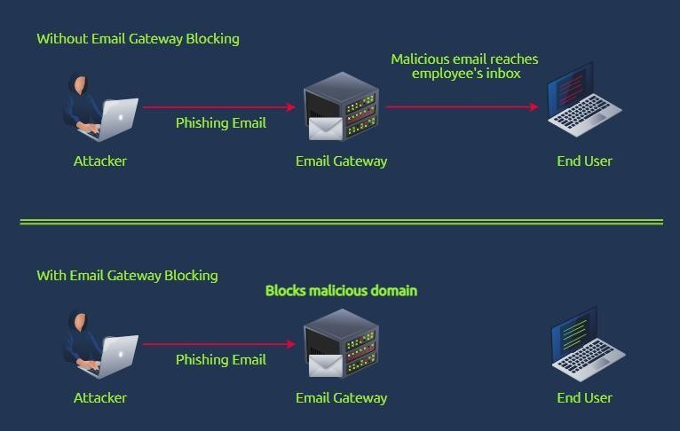

Preventing spam emails from reaching employees’ inboxes reduces the potential attack surfaces of a threat actor in compromising the organisation. Most of the time, an organisation takeover starts with the execution of a malicious attachment or submitting credentials to a phishing website. An additional prevention layer slightly reduces the burden on the users’ phishing awareness capabilities.

Domain Blocking through DNS Sinkhole

DNS Sinkhole is a security measure that mitigates connections to a malicious domain. This is typically done by redirecting all DNS requests from a known malicious domain to a sinkhole, preventing the resolution to their counterpart IP addresses.

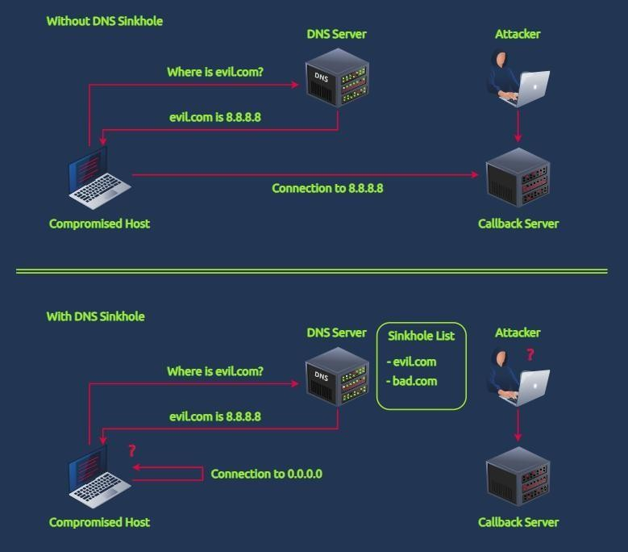

Hunting Sinkholed Domains

Using the logs generated by the SIEM, you are tasked to hunt all domains identified as malicious by your DNS Sinkhole. The Threat Intelligence team has provided a single domain to start with your activity:

- agrosaoxe[.]info

In addition, you may also need the following KQL query templates to complete the investigation:

- dns.question.name: "replace with domain"
- dns.answers.data: "replace with sinkhole IP"

Note that you need to remove the defang in your search query.

Lastly, the events are stored in the filebeat-* index. Ensure the search query is between 02/14/2023 and 02/17/2023. Good luck!

Question:: How many DNS queries to agrosaoxe[.]info have been created?

KQL query to run on the given time frame

dns.question.name: "agrosaoxe.info"
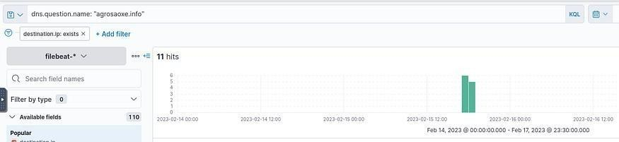

Answer:: 11

Question:: Before deploying the sinkhole configuration, what IPv4 addresses are resolved by agrosaoxe[.]info? (format: IPs in ascending order)
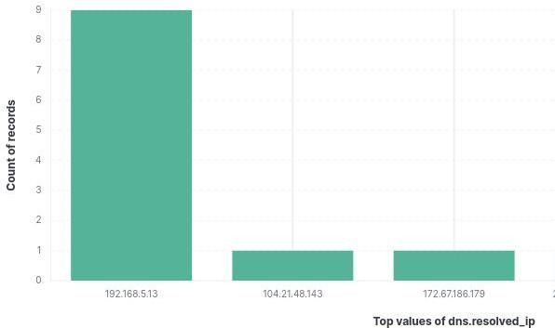

Answer:: 104.21.48.143, 172.67.186.179

Question:: What is the IP address used for DNS Sinkhole?

As discussed after the sinkhole all connection goes to one spot.



Answer:: 192.168.5.13

Question:: How many hits were caused by connections to sinkholed domains?

Use the query:

dns.resolved_ip: "192.168.5.13"

And yes I know this is not the one in THMs description :D but the resolution is the same so dont mess with it. But for faint harted here is the same thing via THMs description.

dns.answers.data: "192.168.5.13"

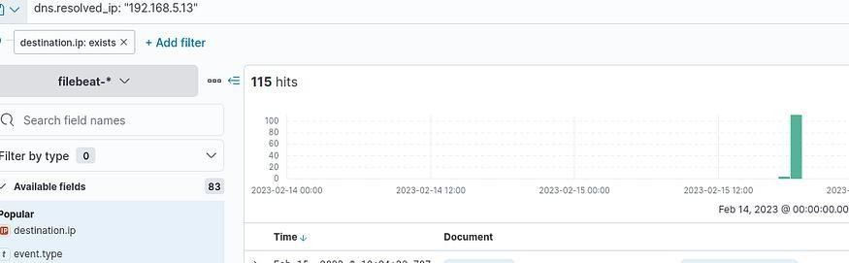
Since we know this is the sinkhole IP resolution. Press enter or click to view image in full size

Answer:: 115

Question:: How many unique domains have been sinkholed?

Since currently we dont care about the domain addresses just the amount visualize the “dns.question.name” field.

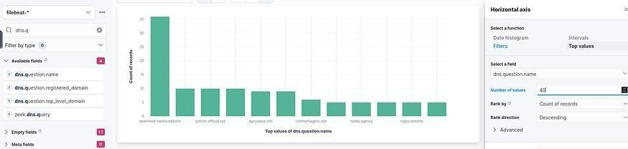
Then set the TOP amount from 5 to like 40 so we can see all columns. Press enter or click to view image in full size

Count the columns and there you go. I’m sure ther’s another method but this was sufficient for me for now.

Answer:: 12

Task 4 — Intelligence-driven Detection

You have successfully deployed preventive mechanisms to mitigate known IOCs in your infrastructure. To maximise the capabilities of your detection and response, you are now tasked to improve the detection capabilities of your tooling.

We have started utilising Threat Intelligence from the previous task to prevent potential compromises from malicious actors. Now, we will leverage Threat Intelligence IOCs to know if something suspicious is happening in our infrastructure effectively.

Optimising Detection Capabilities

Implementing detection based on IOCs may be pretty straightforward, as one may think we can deploy a blocklist rule for known malicious IOCs. An example set of detection use cases is listed below for each common Threat Intel IOC.

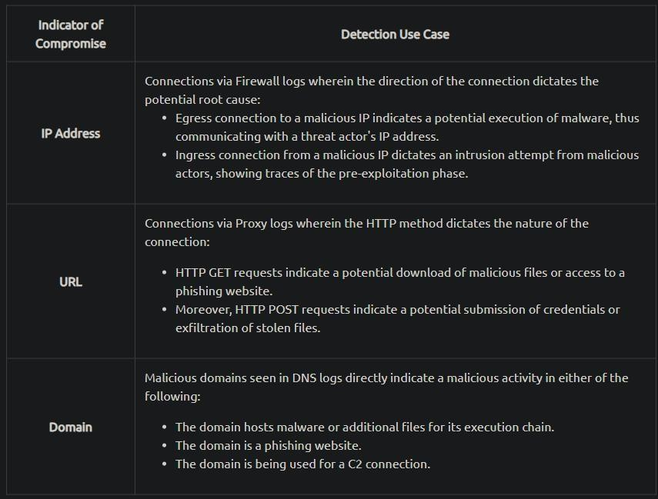

The scenarios above depict the usage of publicly available IOCs to hit any suspicious connections across different data sources such as Firewalls, DNS and Proxy servers. However, this kind of setup may require continuous fine-tuning of rules to accommodate the growth of IOCs.

We can combine some prevention techniques discussed in Task 3 to detect suspicious traffic.
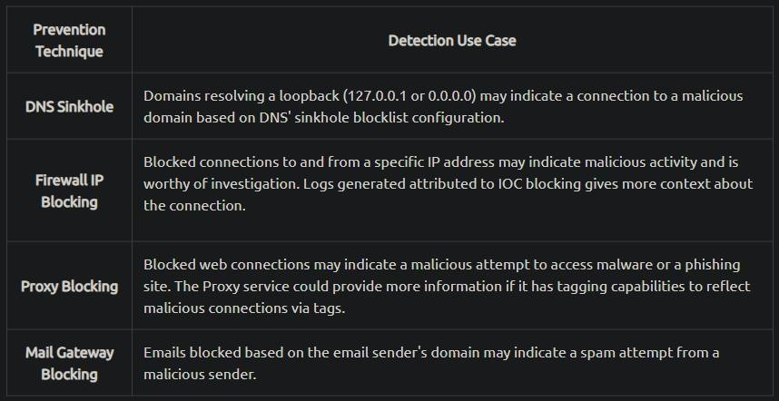

By doing so, the fine-tuning detection rules only rely on blocklist updates from prevention tactics. Hence, this way introduces an optimal way to prevent and detect malicious activity based on Threat Intelligence IOCs.

Sigma Rules Revisited

As discussed throughout the Detection Engineering Module, Sigma is an open-source generic signature language to describe log events in a structured format. This allows for quick sharing of detection methods by security analysts.

In this task, we will use the following Sigma rule to hunt for sinkholed domains.
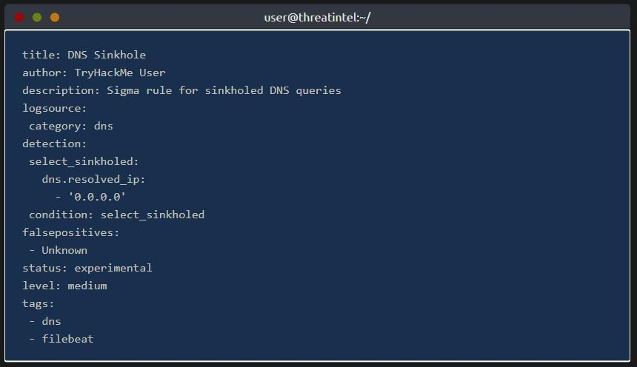

The Sigma rule above hunts for DNS queries resolving 0.0.0.0. As discussed previously, such cases may indicate a connection to a known suspicious domain based on DNS Sinkhole configuration.

Playing with ElastAlert and Uncoder.io

To emulate sample detection, we will use Uncoder.io to translate the previously mentioned Sigma rule into ElastAlert. Ensure that the conversion is set from Sigma to ElastAlert before clicking Translate.

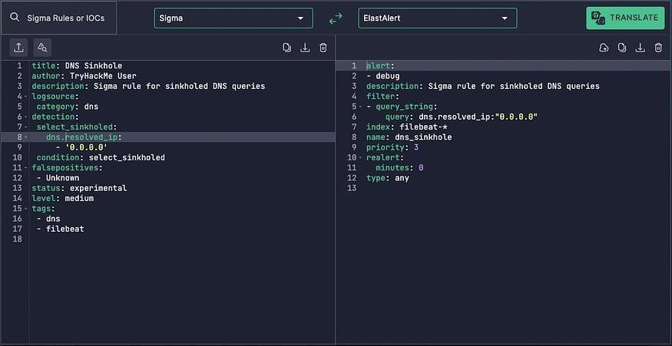

Before we use the generated rule, let’s have a quick run-through about ElastAlert.

ElastAlert is an open-source framework for alerting on anomalies, spikes, or other patterns of interest found in data stored in Elasticsearch. It integrates with Elasticsearch, Kibana, and other tools in the Elasticsearch ecosystem and can be configured to send alerts to various external services such as Email, Slack, PagerDuty, and more.

The resulting ElastAlert rule from Uncoder.io contains the following information:
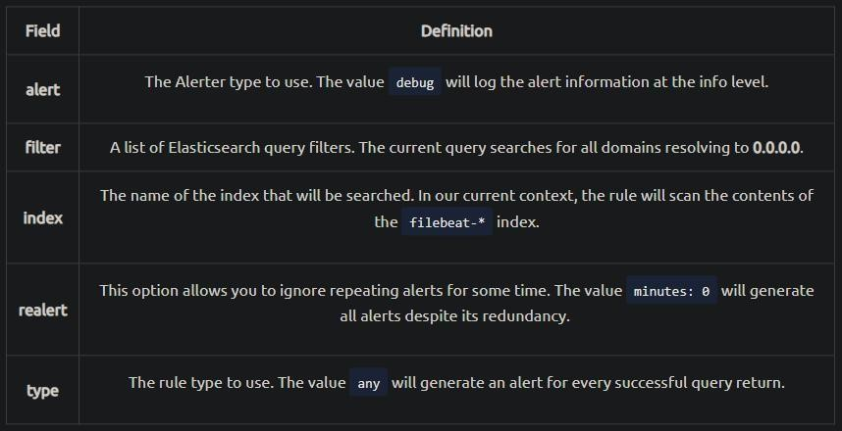

Now that we have introduced ElastAlert, access the machine via SSH using the provided credentials in Task 2 (user:tryhackme) and navigate to the ~/elastalert directory. You may see that the directory contains a config file and a subdirectory.

NOTE BY 0x4C1D:: Follow Task 2 to SSH seriously even from attack machine.

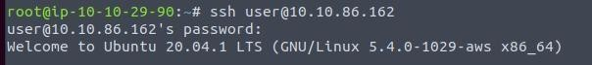
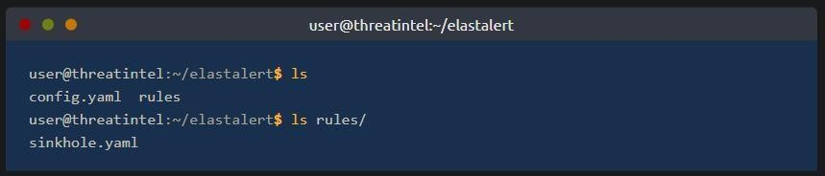

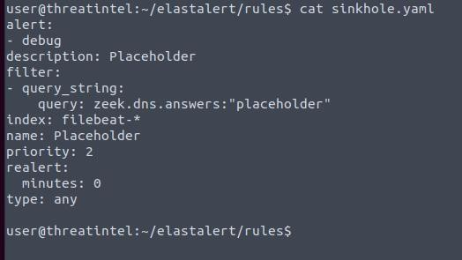
The config.yaml file contains all the configurations needed to connect and query to our Elasticsearch instance, while the ~/elastalert/rules directory contains a placeholder rule. You may populate this rule with the translated Sigma to ElastAlert rule from Uncoder.io.

### Alert Population hard code ### alert:
- debug
description: Sigma rule for sinkholed DNS queries filter:
- query_string:
query: dns.resolved_ip:"0.0.0.0" index: filebeat-*
name: dns_sinkhole priority: 3
realert:
minutes: 0 type: any

After configuring the sinkhole.yaml rule, navigate back to the elastalert directory and start executing ElastAlert.

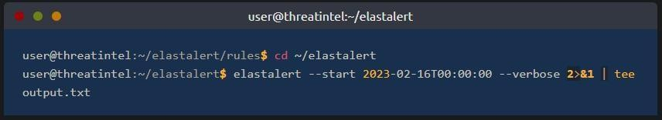
elastalert --start 2023-02-16T00:00:00 --verbose 2>&1 | tee output.txt The elastalert command above can be broken down as:
  - ElastAlert executes the rule we configured starting from 02/16/2023 until the present.
  - It also provides verbose output.
  - Lastly, the snippet uses 2>&1 | tee output.txt to write the results into output.txt. Note that file descriptors were used since the output is being written at the INFO level.

Once the command is executed, you may need to wait a few seconds to finish the initial run. The following string indicates that the execution is finished: X query hits (X already seen), X matches, X alerts sent
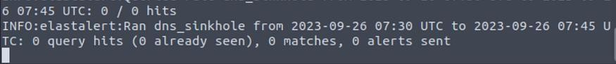

After seeing the string above, you can now stop the execution of the elastalert command with CTRL + C.

To complete the task, review the results written in ~/elastalert/output.txt to answer the questions below.

Question:: What is the value of the alert field in the converted ElastAlert rule?

We just made this rule so it is within the rule
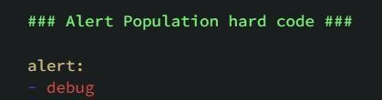

Answer:: debug

Question:: How many alerts were generated by the rule?

Answer:: 40

Question:: How many unique domains were sinkholed via 0.0.0.0? I did this via elastic. Was a lot faster.
First query ‘dns.answers.data: “0.0.0.0”’ Then Visualize by dns.question.name.
After that set the Horizontal axis top count to 10 or 20
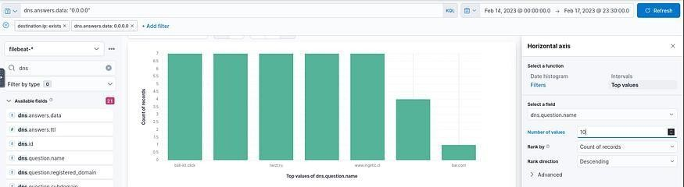

Then count the bars.

Answer:: 7
Question:: What is the sinkholed domain that has .ru TLD? cat output.txt | grep '.ru'

Answer:: twizt.ru

Task 5 — Conclusion

Congratulations! You have completed learning and improving the Security Operation’s capabilities using Threat Intelligence.

In the previous tasks, we have learned the following:

  - The difference between Threat Intelligence Producers and Consumers.
  - Knowing your current needs and capabilities is vital to maximising the usage of Threat Intelligence.
  - Implementation of Intelligence-driven prevention and detection.
  - Revisiting Sigma, Uncoder and Elastalert for the example tooling of intelligence-driven detection.

To conclude, this room focused on leveraging Threat Intelligence to improve the overall capabilities of a Security Operations Center, ranging from detection capabilities to preventive mechanisms that mitigate entirely known threats.

Result:
Successfully analyzed and utilized Threat Intelligence data to identify threats, detect malicious activities, and implement preventive measures, enhancing the overall security posture of the system.

